

Examination Assignment Cover Page

Module Code: | MS5107
Student name and ID | AMIT KUMAR - 24236930

In submitting this script, I am aware that it is my responsibility to adhere to the examination guidelines. Please tick (double click->… or Y/N) for the following:

 | Yes | No
I have read the module owners description/expectations for this exam assignment and the submission process.
I have read the exam assignment guidelines.
I am aware of what the University of Galway plagiarism policy entails.
I have saved the files for submission (e.g., .docx, .xlsx) following strictly the format and naming required (e.g., 12345678_MS5107_ExamAssignment.docx, 12345678_MS5107_ExamAssignment_Q1.xlsx,
12345678_MS5107_ExamAssignment_Q2.xlsx).

Declaration for this Assignment Submission:
By submitting this work, I confirm that it is entirely my own and has not been copied or shared in whole or in part with others. I understand that this is individual assignment and that working with another person on an individual assignment, including sharing solutions, ideas, discussing solutions, or approaches to solutions, is considered to be collusion.
I am aware of what the University of Galway plagiarism policy entails. https://www.universityofgalway.ie/academicintegrity/policies/.

Table of Contents
Q1. Optimisation modelling 4
Problem Formulation 4
Decision Variables 4
Objective Function 5
Constraints 5
Solution Using MS Excel Solver 5
Data Input 6
Solver Configuration 6
Optimisation Results 7
Optimal Production Quantities 7
Profit 7
Resource Utilization 7
Interpretation of Results 7
Production Recommendations: 7
Constraints Analysis 7
Shadow Prices: 8
Objective Sensitivity: 8
Q2: Data mining and predictive analytics. 8
Introduction 8
CRISP-DM Methodology 8
Business Understanding 9
Data Understanding 9
Data Preprocessing 9
1. Handling Missing Values 9
2. Feature Selection 9
3. Data Encoding 10
4. Outlier Detection and Treatment 10
5. Normalization and Standardization 10
6. Data Partitioning and Oversampling 10
Modelling 11
1. Logistic Regression 11
2. Classification Tree 11
3. Random Tree 11
4. Neural Network 12
5. Bagging for Decision Trees 12
6. Boosting for Decision Trees 12
Model Evaluation 13
Key Insights 13
Model Proposal 13
Best Performance: 14
Additional Insights 14
Conclusion 14
References 15

Q1. Optimisation modelling
Introduction: Celtic Candles Inc. manufactures decorative candles and has entered into a contract to supply a set of special holiday candles to 8,500 stores.
Objective: The company seeks to maximize profits while adhering to resource constraints (wax, wick, and fragrance), contractual display requirements, and the total display area across all stores.

Problem Formulation
The problem is modelled as a linear programming (LP) problem with the following components:

Decision Variables
Let:
- X1​: Number of Large Jars produced
- X2​: Number of Small Jars produced
- X3​: Number of Large Pillars produced
- X4​: Number of Small Pillars produced
- X5​: Number of Votive Packs produced
These decision variables represent the quantities of each product to manufacture.

Objective Function
The objective is to maximize profit:
Maximize Z = 0.25X1+0.20X2+0.24X3+0.21X4+0.16X5​
Where:
- 0.25,0.20,0.24,0.21, and 0.16 are the profits per unit for Large Jars, Small Jars, Large Pillars, Small Pillars, and Votive Packs, respectively.

Constraints
Resource Constraints
- Wax Usage: 0.5X1+0.25X2+0.5X3+0.25X4+ 0.3125X5 ≤ 200,0000.
- Fragrance Usage: 0.24X1+0.12X2+0.24X3+0.12X4+0.15X5 ≤ 100,0000.
- Wick Usage: 0.43X1+0.22X2+0.58X3+0.33X4+0.8X5 ≤ 250,0000.
Display Requirements Per Store
- Combined display space for Large Jars and Large Pillars must be at least 2 feet per store, multiplied by the total number of stores:
0.48X1+0.23X3 ≥ 2×8,5000.
- Combined display space for Small Jars and Small Pillars must be at least 1.5 feet per store, multiplied by the total number of stores:
0.24X2+0.23X4 ≥ 1.5×8,5000.
- Display space for Votive Packs must be at least 1 foot per store, multiplied by the total number of stores:
0.26X5 ≥ 1×8,5000.
Business Constraints
More jars than pillars must be produced: X1+X2 ≥ X3+X4
Non-Negativity Constraints
All variables must be non-negative: X1,X2,X3,X4,X5 ≥ 0

Solution Using MS Excel Solver
The linear programming problem was implemented and solved using Excel Solver with the following configuration:

Data Input
All profit coefficients, resource requirements, and constraints were organized into a structured Excel table.
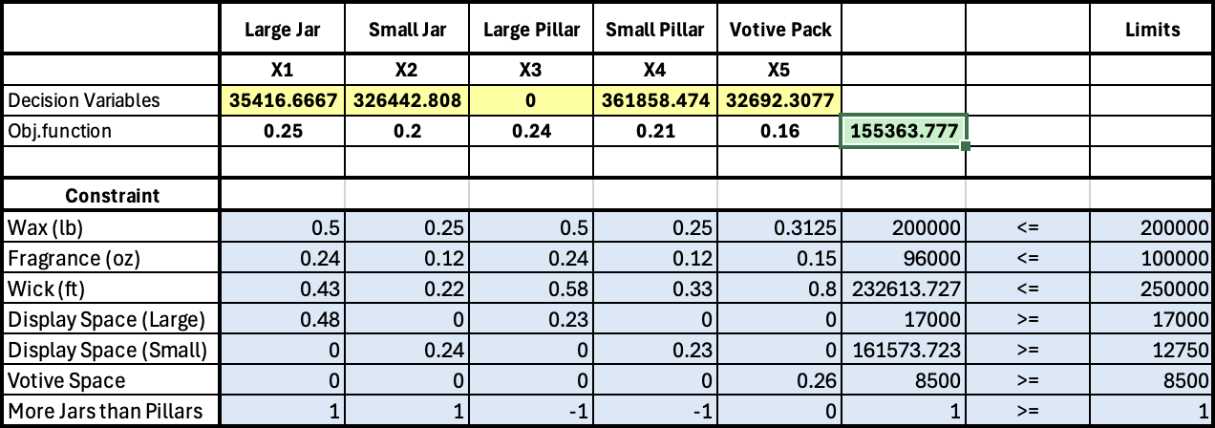

Solver Configuration
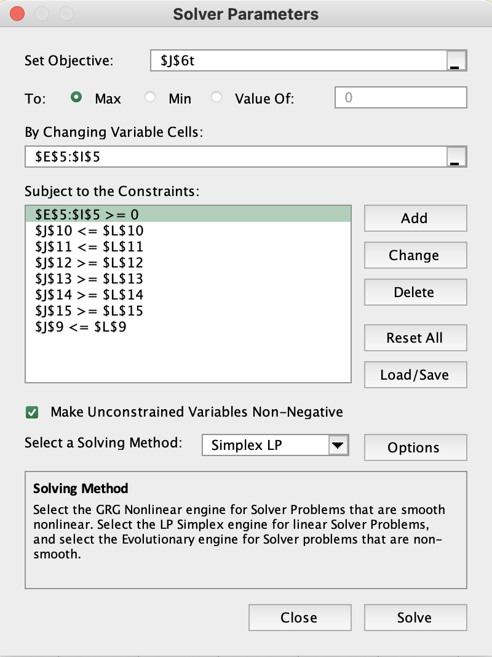
- Objective: Maximize Z (total profit).
- Changing Variables: X1,X2,X3,X4,X5.
- Constraints:
  - Material constraints for wax, fragrance, and wick.
  - Display requirements across all 8,500 stores.
  - Business conditions as mention above.
- Solving Method: Simplex LP (Linear Programming).

Optimisation Results

Optimal Production Quantities
Product Type | Optimal Quantity
Large Jar (X1​) | 35,417 units
Small Jar (X2​) | 326,442 units
Large Pillar (X3​) | 0 units
Small Pillar (X4​) | 361,859 units
Votive Pack (X5​) | 32,692 units

Profit
The maximum profit achievable is €155,363.777.

Resource Utilization
Resource | Utilized Amount | Remaining Amount
Wax | Fully utilized | 0 lb
Fragrance | Partially used | Available
Wick | Partially used | Available

Interpretation of Results

Production Recommendations:
Maximizing the production of Small Jars and Small Pillars, as they are profitable and resource-efficient.
  - Producing a moderate number of Large Jars.
  - No production of Large Pillars because of their resource requirements and lower profitability.
  - Producing Votive Packs just meets the minimum display requirement.

Constraints Analysis
Binding Constraints:
From the Answer Report and Sensitivity Report, the following constraints are binding (fully utilized):
- Wax (lb): No slack remaining.
- Display Space (Large): Fully satisfied at 17,000.
- Display Space (Votive): Exactly meets the foot requirement for 8500 stores.
- More Jars than Pillars: Enforced with no slack.
Non-Binding Constraints:
- Fragrance and Wick have remaining availability (slack), indicating surplus capacity.

Shadow Prices:
  - Wax Constraint: The shadow price of €0.82 indicates that for every additional unit of wax (1 lb), profit would increase by €0.82, within the allowable increase of 8,333 units.
  - Display Space (Large): A negative shadow price of -0.3229 shows that increasing this constraint would decrease profitability slightly.

Objective Sensitivity:
  - The objective coefficients for Small Jars and Small Pillars have tight allowable decreases (e.g., 0.01 for Small Jars), indicating sensitivity to price reductions.

Q2: Data mining and predictive analytics.

Introduction
Western Alliance Bank aims to optimize its marketing strategies for term deposits by developing a predictive model to identify customers likely to subscribe to term deposits. Using historical telemarketing campaign data, this report outlines the development of a predictive model using the CRISP-DM methodology, evaluates its performance, and provides actionable insights for future marketing campaigns.

CRISP-DM Methodology
The CRISP-DM (Cross-Industry Standard Process for Data Mining) methodology is a structured framework for building predictive models, consisting of six phases:
- Business Understanding: Define project goals and objectives.
- Data Understanding: Collect and explore the data to identify key patterns and issues.
- Data Preparation: Clean, preprocess, and transform the data for modelling.
- Modelling: Apply machine learning algorithms to develop predictive models.
- Evaluation: Assess model performance to ensure it meets business goals.
- Deployment: Implement the model to generate actionable insights.
This methodology was followed to develop the predictive model, ensuring a systematic approach from understanding the business problem to delivering a reliable solution.

Business Understanding
The goal of this project is to predict whether a bank client will subscribe to a term deposit based on historical telemarketing campaign data. The bank aims to optimize its marketing strategy by identifying high-potential customers and reducing the costs of ineffective outreach.
By analysing the dataset provided, the bank can build a predictive model to:
- Identify key characteristics of clients likely to subscribe.
- Improve targeting strategies for future campaigns.
- Optimize resource allocation to focus on high-potential leads, increasing campaign efficiency and ROI.

Data Understanding
The dataset consists of 16 input variables and 1 output variable. The inputs include:
Client Demographics:
  - Age, job type, marital status, education level.
  - Credit status (default), housing loan, and personal loan.
Financial Indicators:
  - Average yearly balance in euros.
Campaign-Related Attributes:
  - Contact type (telephone/cellular), last contact duration, day, and month of contact.
  - Number of contacts during the campaign and from previous campaigns.
  - Outcome of previous campaigns (success/failure).
Target Variable:
  - y: Indicates whether the client subscribed to a term deposit (binary: “yes” or “no”).
  - The target variable is unbalanced.

Data Preprocessing
Data preprocessing is a critical step to ensure the dataset is clean, balanced, and suitable for building accurate predictive models. The following steps were performed:

1. Handling Missing Values
The dataset was checked for missing values, and none were found. This ensured no imputation or removal of records was required.

2. Feature Selection
- The day and month attributes were excluded from the analysis because they provide redundant information similar to pdays (number of days since the last contact).
- pdays offers a more comprehensive measure of recency, which is more relevant for predicting client behaviour.

3. Data Encoding
Categorical variables such as job, marital status, education, and others were encoded using the "Category Scores" option in Analytical Solver. This method assigns numerical scores to categories, ensuring the variables are compatible with machine learning models.

4. Outlier Detection and Treatment
Outliers were detected using the Z-Score method for numerical variables:
- Affected Variables: Age, balance, duration, campaign, pdays, and previous.
Treatment:
- Outliers were removed for campaign, previous, and pdays because these attributes directly influence the campaign's performance metrics and removing them improves model robustness.
- Outliers were not removed for age, balance, and duration because:
  - Age: Natural variation in client demographics is expected.
  - Balance: High or low balances provide critical insights into client financial behaviour.
  - Duration: Longer call durations often signal higher engagement, which is significant for subscription predictions.

5. Normalization and Standardization
Both normalization and standardization were applied as per the model requirements using options in the model dialog box/tab of Analytical Solver. This ensures that numerical variables are scaled appropriately for algorithms sensitive to data range.

6. Data Partitioning and Oversampling
The dataset was split into training (70%) and testing (30%) sets using partitioning with oversampling to address class imbalance.
- Oversampling for this data - The target variable y ("yes" or "no") was highly imbalanced, with significantly fewer "yes" cases. Oversampling increases the representation of the minority class ("yes") in the training data, helping models learn patterns related to clients likely to subscribe.

- Significance of Predicting "Yes":
  - Accurately predicting "yes" cases has high business value as it directly impacts the success of the marketing campaign and bank revenue.
  - A high F1 score and improved recall ensure that the model effectively identifies clients likely to subscribe, minimizing missed opportunities.
Before Oversampling:
- High accuracy was observed, but this was misleading due to the overwhelming presence of "no" cases.
- Recall and F1 scores for the "yes" class were very low, indicating poor performance in identifying clients likely to subscribe.
After Oversampling:
- Recall and F1 scores for the "yes" class significantly improved.
- The model achieved better balance, ensuring reliable predictions for both classes ("yes" and "no").
The improved F1 score validates the suitability of the data, making it suitable for future analysis.

Modelling
The predictive modelling process involved testing multiple machine learning algorithms to determine the best-performing model for predicting whether clients subscribe to term deposits. The following models were evaluated: Logistic Regression, Classification Tree, Random Tree, Neural Network, Bagging, and Boosting.

1. Logistic Regression
- Overview: Logistic Regression is a baseline linear model that predicts the probability of binary outcomes based on input features.
- Model Details: It assumes a linear relationship between the features and the log-odds of the target variable.
- Performance:
  - Accuracy: 77.78%
  - Recall (Sensitivity): 76.25%
  - Precision: 80.86%
  - F1 Score: 0.7848
- Observation:
Logistic Regression achieved moderate accuracy and precision but struggled to identify the minority "yes" class. Its recall and F1 score were lower compared to advanced models, indicating limitations in handling non-linear relationships and class imbalance.

2. Classification Tree
- Overview: A decision tree splits the data into subsets based on feature values, creating decision rules to classify the target variable.
- Model Details: A minimum-error tree was generated to reduce overfitting.
- Performance:
  - Accuracy: 82.32%
  - Recall: 88.12%
  - Precision: 80.48%
  - F1 Score: 0.8413
- Observation:
The Classification Tree showed significant improvement in recall and F1 score over Logistic Regression. However, the tree was prone to overfitting, which reduced its generalization to unseen data.

3. Random Tree
- Overview: A random tree introduces randomness in feature selection at each split to reduce feature bias and overfitting.
- Performance:
  - Accuracy: 82.20%
  - Recall: 87.41%
  - Precision: 80.70%
  - F1 Score: 0.8392
- Observation:
While Random Tree improved upon single decision tree performance, it remained slightly unstable compared to ensemble methods like Bagging and Boosting.

4. Neural Network
- Overview: A feedforward Neural Network with 1 hidden layer and 730 epochs was trained to capture non-linear patterns in the data.
- Performance:
  - Accuracy: 53.41%
  - Recall: 13.78%
  - Precision: 90.63%
  - F1 Score: 0.2392
- Observation:
The Neural Network significantly underperformed. Its inability to identify the minority "yes" class led to very low recall and F1 scores. The imbalance in the dataset likely caused the model to focus disproportionately on the majority "no" class.

5. Bagging for Decision Trees
- Overview: Bagging (Bootstrap Aggregating) trains multiple decision trees on bootstrapped subsets of the data and averages their predictions to reduce variance and overfitting.
- Performance:
  - Accuracy: 82.07%
  - Recall: 89.78%
  - Precision: 79.25%
  - F1 Score: 0.8419
- Observation:
Bagging improved model stability and recall compared to single decision trees. However, its performance remained below Boosting, which more effectively reduced bias.

6. Boosting for Decision Trees
- Overview: Boosting sequentially trains decision trees, focusing on correcting errors made by previous models to improve overall accuracy and performance.
- Performance:
  - Accuracy: 86.99%
  - Recall: 92.40%
  - Precision: 84.56%
  - F1 Score: 0.8831
- Observation:
Boosting achieved the highest accuracy, recall, and F1 score among all models. Its ability to focus on misclassified cases allowed it to effectively identify the minority "yes" class, making it the most suitable model for this business problem.

Model Evaluation
Each model was assessed based on key performance metrics, including accuracy, recall (sensitivity), precision, and F1 score. The following table summarizes the performance of all models:
Model | Accuracy | Recall | Precision | F1 Score
Logistic Regression | 77.78% | 76.25% | 80.86% | 0.7848
Classification Tree | 82.32% | 88.12% | 80.48% | 0.8413
Random Tree | 82.20% | 87.41% | 80.70% | 0.8392
Neural Network | 53.41% | 13.78% | 90.63% | 0.2392
Bagging (Decision Tree) | 82.07% | 89.78% | 79.25% | 0.8419
Boosting (Decision Tree) | 86.99% | 92.40% | 84.56% | 0.8831

Key Insights
- Logistic Regression performed poorly for the "yes" class due to its linear nature and inability to handle complex patterns.
- Classification Tree and Random Tree improved recall significantly but were prone to instability and overfitting.
- Neural Network failed to generalize and showed very low recall, making it unsuitable for the imbalanced dataset.
- Bagging reduced overfitting and improved recall compared to single trees, but it was outperformed by Boosting.
- Boosting achieved the best performance, with the highest recall (92.40%) and F1 score (0.8831). It effectively handled the class imbalance and accurately identified clients likely to subscribe to term deposits.

Model Proposal
Based on the analysis and evaluation of multiple machine learning models, Boosting for Decision Trees is the proposed model for predicting whether clients will subscribe to term deposits. This model stands out because:

Best Performance:
- Boosting achieved the highest accuracy (86.99%), recall (92.40%), and F1 score (0.8831).
- High recall ensures that the model accurately identifies the minority "yes" class, which is critical for the bank's marketing success.
- How Boosting Works: Boosting builds decision trees one after the other in a sequence. Each new tree focuses on correcting the mistakes made by the previous ones, giving more attention to the difficult cases. By combining the predictions of all trees, Boosting produces highly accurate results. This iterative process allows the model to handle complex patterns in the data and improve performance, especially on imbalanced datasets like this one.
- Why This Model is the Best Choice:
  - Business Value: Boosting's ability to capture the "yes" class helps the bank target potential clients more effectively, increasing the success rate of term deposit subscriptions.
  - Class Imbalance: The model effectively handles the imbalance in the data (fewer "yes" cases compared to "no"), by using oversampling.
- Model Improvements: During preprocessing, oversampling techniques were applied to address the class imbalance. This significantly improved the model’s ability to predict the "yes" class, as seen in the high recall and F1 score. Previously, simpler models like Logistic Regression achieved high accuracy but failed to identify "yes" cases effectively, which would have been misleading for business decisions.

Additional Insights
- Key Features: The most important predictors influencing a client’s decision to subscribe were:
  - Previous Campaign Outcome: Clients who had a successful previous campaign are more likely to subscribe.
  - Contact Duration: Longer calls correlate with higher chances of subscription.
  - Age and Balance: Middle-aged clients with stable financial balances showed higher likelihood of subscribing.

Conclusion
The Boosting for Decision Trees model is the most effective solution for predicting client subscriptions to term deposits. It achieved the highest accuracy (86.99%), recall (92.40%), and F1 score (0.8831), ensuring reliable identification of the "yes" class, which is critical for the bank's marketing success.
The model’s ability to handle class imbalance and focus on difficult-to-predict cases makes it ideal for targeting high-potential clients. Key insights, such as the importance of previous campaign outcomes, contact duration, and client profiles, provide actionable strategies to improve future marketing campaigns.
By implementing this model, the bank can optimize its resources, improve campaign efficiency, and increase term deposit subscriptions, driving better business outcomes.

References
- Nachev, A. (2024). Class Notes on Business Modelling & Analytics. MS5107, University of Galway.
- Han, J., Kamber, M., & Pei, J. (2012). Data Mining: Concepts and Techniques. 3rd ed. Burlington: Morgan Kaufmann Publishers.
- Shmueli, G., Bruce, P. C., Patel, N., Yahav, I., & Lichtendahl, K. (2017). Data Mining for Business Analytics: Concepts, Techniques, and Applications with XLMiner. 3rd ed. Hoboken: Wiley.
- He, H., & Garcia, E. A. (2009). "Learning from Imbalanced Data." IEEE Transactions on Knowledge and Data Engineering, 21(9), pp. 1263–1284.
- Breiman, L., Friedman, J., Olshen, R., & Stone, C. (1984). Classification and Regression Trees. Boca Raton: CRC Press.

